LOOK + COVER  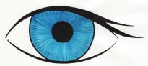 | WRITE  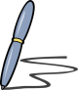 | CHECK | WRITE | WRITE | WRITE | CHECK

